Edge Detection
Detection edge of a image using different edge detection method.
Read image from the link
rgb = imread('C:\Users\nishi_000\Desktop\Extra\simul2.jpg');
a = rgb2gray(rgb); % Convert RGB to gray scale
- edge detection using different operator
b = edge(a, 'canny');
c = edge(a, 'sobel');
d = edge(a, 'prewitt');
e = edge(a, 'log');
f = edge(a, 'Roberts');
g = edge(a, 'zerocross');
Show image in 3*3 grid
subplot(3,3,1);
imshow(a);
title('input image');
subplot(3,3,2);
imshow(b);
title('canny edge');
subplot(3,3,3);
imshow(c);
title('sobel edge');
subplot(3,3,4);
imshow(d);
title('prewitt edge');
subplot(3,3,5);
imshow(e);
title('log edge');
subplot(3,3,6);
imshow(f);
title('Roberts edge');
subplot(3,3,7);
imshow(g);
title('zerocross');
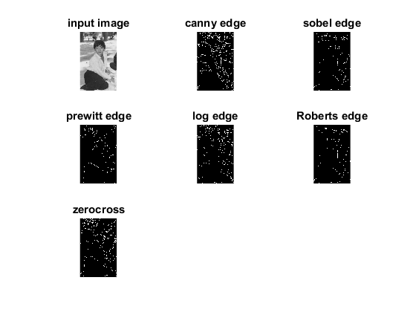
Published with MATLAB® R2015a

